VICTORIOUS EDUCATION SERVICES
P.4 SOCIAL STUDIES LESSON NOTES
TERM ONE 2018

Week 2

TOPIC: LOCATION OF OUR DISTRICT
SUB-TOPIC: MAPS AND PICTURES

A map is a drawing of an object as seen from above.
A picture is a drawing of an object as from aside.
ILLUSTRATIONS

PICTURE MAP
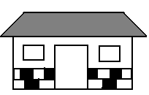
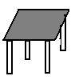
 | 
 | 

ACTIVITY
- Draw a map of our class
- Differences a between a map and a picture

A map A picture
It is drawn as seen from above It is seen and drawn from aside
It cannot be easily identified It is easily identified
Big masses can be drawn Big masses can be drawn
It is easy to draw
Map symbols (Defn: importance and common map symbols) It is not easy to draw

Map symbols

Map symbols are signs and colours used on a map.

Why are map symbols used on a map?

To avoid congestion on a map/ to make the map tidy
To make map reading easy
Common symbols used on a map




Note; include map symbols of two types of lakes, rivers hills, swamps, airports, inland and seaports, mountain and mountain peaks, bridge etc.

Elements of a good map
These are things that a good map should have
- A scale - It helps a map reader to measure distance
- A compass direction - Helps to show direction of places on a map
- A key - Helps to interpret symbols used on a map
- A title - Tells us what the map is about.
- Boundary/Frame - Gives shape to the map and encloses.

NB: A compass direction is an element of a map used to find the direction of places on a map.

It has four major points; North, East, South and West.
These four major points are called; Cardinal points.
There are other four points between cardinal points called semi-cardinal points/ secondary points.

References
Mk. SST plok4pg 1-4 Sharing our world bk4 pg 3
Mk SST Trs guide bk4 pg 28-31 Comprehensive SST pbk4 pg 1-3
Elements of a good map
These are things that a good map should have.
a) A scale
b) A compass direction
A compass is an instrument used for finding directions of

A compass also has cardinal points and semi cardinal points (secondary)
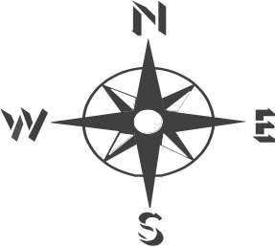

Cardinal points Secondary points
North North East
South South East
East North West
West South West

NOTE: When at rest, compass points in the north
A face of a compass is like a circle. There fore directions are measured in degrees

Reference
Sharing our world pbk4 pg 3-5
MK SST pbk 4 pg 3
Comprehensive SST bk4 pg 2.3

SUB TOPIC: LOCATING DIRECTION OF PLACES ON A MAP
Ways of finding direction of places
- By using a compass
2. Using the position of shadows
3. Using the position of the sun and stars
4. Using the major land marks e.g. hills, valleys, mountains etc.
5. By using longitudes and latitudes. (grid reference)

People who use a compass in their daily work
Pilots
Sailors
Soldiers
Frogmen
Mountain climbers
Rally drivers

Longitudes and latitudes
Longitudes are imaginary lines drawn on a map running from North to South
The major line of longitude is called the Prime Meridian or Greenwich Meridian.
It is marked 0⁰

Major longitude
-The major line of longitude is called the Prime Meridian. It is also called the Greenwich Meridian
-International Date Line 180⁰
The Greenwich divides the earth into two equal parts called hemispheres. Namely:
- The Eastern hemisphere
- The Western hemisphere
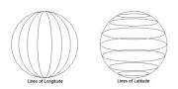
Illustration

Importance of longitudes
- They help to locate places on a map
- They help to determine time of the day

Reference
MK SST bk4 pg 32, Trs guide
Uganda pri. Sch. Atlas

Latitudes
Latitudes are imaginary lines drawn on a map running from East to West
The major line of latitude is called the Equator.
It is marked 0⁰

Illustration
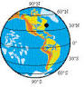

Main lines of latitude
Equator 0⁰
Tropic of cancer 23.5⁰ N
Tropic of Capricorn 23.5⁰ S

Activity
- Early on a sunny morning stand outside so that
- Your right hand points towards the rising sun (East)
- Your left hand will point the west (where it sets)
- You will be facing North and your back will be in the South

Using the position of the sun and shadow
In the morning, the sun is in the East and in the evening it is in the West
So when the sun is in the East (morning the shadow goes to the West.
When the sun is in the West the shadow goes to the East
At noon, since the sun is above (over head). The shadow will be at the centre of the object or around it.

Different objects can be used e.g. tin, table, house etc
By using land marks such as a hill, mountain, a big tree, vegetation etc

Reference
Mk SST pbk4 pg 8
Comprehensive SST pg 2-3
Sharing our world bk4 pg 3

REVISION EXECISE
- Explain the meaning of the term map
- Write down four differences between a map and a picture
- Draw the picture of a tree in the space provided
4. Draw the following map symbols
Crossroads
5. What name is given to the four major points of a compass?
6. Why do we need a scale on a map?
7. Where does a compass point while at rest?
8. Identify any two ways of finding directions of places on a map
9. Mention any two groups of people who use a compass
10.Sandra was going to school in the morning. In which direction was the sun?

TOPIC: LOCATION OF OUR DISTRICT
SUBTOPIC: POSITION AND SIZE OF OUR DISTRICT
Our country is Uganda. Our district is Kampala

A map of Uganda showing the location of Kampala

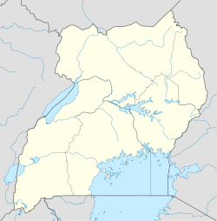

SUB TOPIC: POSITION AND SIZE OF OUR DISTRICT
DIFFERENT REGIONS IN UGANDA

- Northern region
- Central region
- Eastern region
- Western region
- South Western region
- NorthWestern region/Westnile region.
- Northern Eastern region/ Karamoja.

Kampala is found in the central region

REFERENCE
MK pbk4 pg 1-5
Sharing our world pg 3-8
Comprehensive SST pbk 4 pg 2-9

WEEK 3
Sub topic: Districts and regions in Uganda

Region Districts Tribes
Northern Kitgum, Gulu,Pader. Acholi
Apac ,Lira, Langi
North Western Adjuman, Nebbi Yumbe Alur Lugbara, Madi
Arua Moyo Kakwa, Jonam
North Eastern Kotido, Moroto Karimojong, Tepeth
Nakapiripirit Suk, Labour, Ateker
Western Masidi, Hoima, Kabale Banyoro, Batoro
Kasese Kaborole Kyejojo Bakonjo
Kamwenge Bundibugyo Bamba
Central Kampala, Mpigi, Rakai Baganda, Baruli
Mukono, Kiboga, Masaka Banyara
Luwero Mubende, Wakiso Baziba
Kayunga Ssembabule
Eastern Jinja, Iganga Palisa Iteso, Basoga
Tororo, Mbale, Soroti, Busia Banyole, Kumam
Kamuli, Sironko, Bugiri Bagwere, Bakenyi
Mayuge, Kapchorwa, Kumi Jopadhola
Western Ntungamo, Bushenyi Banyankole
Kisoro, Kabale, Kanungu Bakiga
Mbarara, Rukungiri Bafumbira

New districts in Uganda

New districts Mother district
Bunyangabu
Rukiga
Namisindwa Manafwa
Kyotera Rakai
Packwach Nebbi

A map of Uganda showing district

Reference:
MK SST bk 4 pg 1-5
Sharing our world bk4 pg 4
Comprehensive SST bk4 pg4.

DIVISION/ URBAN COUNCILS OF KAMPALA
- Kampala is the capital city of Uganda
- It is found in the central region
- It occupies an area of 197 km²
- Kampala city is headed by the Lord Mayor ( Erias Lukwago) as the political head
- Kampala is also headed by an appointed executive Director (Mrs. Jennifer Musisi) as the administrative head
- Kampala district is under the ministry of Kampala Affairs.
- The current minister for Kampala affairs is Hon. Betty Kamya
- Kampala city is under the Kampala Capital City Authority (KCCA)
- Kampala has a population of about 1,516,210 people according to 2014 national census

DIVISIONS OF KAMPALA

Kampala district is made up of five divisions also called urban councils
These include; Rubaga, Central, Kawempe, Nakawa and Makindye
Nakawa is the biggest and the smallest is Central

A map showing division/urban councils of Kampala.

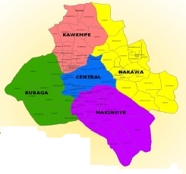

Important places in the divisions.

- Central division Parliamentary building, state house, banks,
government offices.
- Kawempe division Makerere university, Mulago hospital
- Rubaga division Rubaga hospital,Rubaga cathedral
- Makindye division Army barracks.
- Nakawa division Century bottling company, Makerere
University Business School (MUBS)

Other important places: Banks, schools, hospitals, recreation centres etc
References
MK.SST PBK4 pg 7
Prim SST bk4
Uganda pri. Sch. Atlas pg 28.

Importance of Kampala
- It is the capital city of Uganda
- Kampala has the biggest number of social centres e.g hospitals, schools, medical services.
- Kampala has all ministerial headquarters.
- It has the parliament building
- It is the largest commercial centre of Uganda
- It is the most industrial centre of Uganda
- It has the natural museum.

Problems facing Kampala
- There is traffic jam especially in the morning and evening
- Kampala city is densely populated.
- Roads in Kampala city have pot holes, others are narrow.
- There are many robbers in Kampala.
- Accommodation in Kampala is expensive
- There are murderers in Kampala city
- Many people are poor and they live on streets.

Reference: MK. SST PBK4 pg7
Sharing our world pbk4 pg 6-8

REVISION EXERCISE
- In which district is our school?
- Name the district that boarder Kampala in the
North South East, West
- Apart from Kampala, write down any two districts fund in the central region
- Identity two districts in the West Nile
- Write down any three new districts in Uganda
- Why does the government create new districts?
- Name the smallest and biggest divisions of Kampala
- State one port found in Kampala district
- Write KCCA in full
- Mention two important places in Kampala
- Write down two problems faced by people living in Kampala
- Identify the solution to the above mentioned problem

TOPIC: LOCATION OF OUR DISTRICT IN UGANDA
SUBTOPIC: LATITUDES AND LONGITUDES

Lines of latitude
These are parallel mapping lines

Note: The Equator is the major line of latitude
The equator divides the earth into two parts called hemispheres. Namely;
- Northern Hemispheres
- Southern Hemispheres

Districts crossed by the equator
- Kasese
- Sembabule
- Mpigi
- Kiruhura
- Wakiso
- Kalungu
- Kamwenge
- Ibanda etc

Importance of latitude
- Latitudes help to locate places on a map
- They help us to determine the climate of places

Lines of longitude
Lines of longitude are imaginary lines drawn on a map running from North to South.
Major longitude
-The major line of longitude is called the Prime Meridian. It is also called the Greenwich Meridian
-International Date Line 180⁰
The Greenwich divides the earth into two equal parts called hemispheres. Namely:
- The Eastern hemisphere
- The Western hemisphere

Importance of longitudes
- They help to locate places on a map
- They help to determine time of the day

Reference
MK SST bk4 pg 32, Trs guide
Uganda pri. Sch. Atlas

WEEK 5
TOPIC: PHYSICAL FEATURES AND VEGETATION
SUBTOPIC: Physical features in our district
CONTENT:
What are physical features?
Physical features are natural landforms of an area.

Examples of physical features
- Mountains,
- Plateau,
- Plains,
- Valley,
- Hills,
- Lakes and rivers
- Plains or low lands

Plateau
A plateau is a raised flat topped piece of land. It is also called a table land
A plateau has features like: lakes, rivers, plains, hills, valleys, rocks, springs, swamps and wells

Activities carried out on plateau
Industrialization, Farming, Lumbering, Fishing, Tourism
- Altitude is the height of the land above sea level
- Relief is the difference in height between landforms
Importance of plateau
- They have fertile soil for farming
- They are good for settlement
- They have lakes for fishing
- They are sources of rivers

REFERENCE: Monitor S.S.T pbk4 pg 5
MK Std SST bk4 Trs guide pg 37-38
MK pbk4 pg 10

MOUNTAINS
- A mountain is a big piece of land high above the land around it
- A peak is the highest point on a mountain
- A mountain range is a series of connected mountains
Types of mountains
- Block mountains
These are formed by faulting e.g. mountain Rwenzori in western Uganda
- Volcanic mountains
These are formed by a process known as volcanicity
Here, old mount rocks crack. Down the earth’s surface, temperature is high so the rock down melts. The molten rock (magma) is forced up due to pressure through the cracks. When magma reaches on the surface of the earth, it solidifies to form a volcanic mountain.

Examples of volcanic mountains
- Mt. Elgon
- Mt.Moroto
- Mt.Kadam
- Mt.Morungole
- Mt.Mufumbiro
Importance of mountains
- Mountains help in rainfall formation.
- They provide rocks for construction.
- Mountain slopes are used for crop growing.
- Some mountains are sources of rivers.
- We get minerals from mountains.
- Slopes of mountains are used for human settlement.
- Mountains attract tourists.

Dangers of mountains
- Mountains are habitats of dangerous animals.
- They limit construction of roads and industries.
- Mountain eruption leads to the death of people and plants.
- They are hideout places of wrong people.
- Mountain slopes encourage soil erosion.

REFERENCE:
MK SST Teacher’s guide pg 39-40
MK Std SST pbk4 pg 11
Comprehensive SST pbk4 pg 8-9
Monitor SST pbk4 pg 5

Key
Mountain Peak District Height
Mt.Moroto Napak Moroto 3084 m
Mt.Kadam Dehasien Nakapiripirit 3068 m
Mt.Elgon Wagagai Mbale 4321 m
Mt.Mufumbiro Muhavura Kisoro 4127 m
Mt.Rwenzori Margherita Kasese 5109 m

Reference
Atlas pg 6
MK S.S.T pbk4 Teacher’s guide pg 39-40
REVISION EXERCISE
- Define the term physical features
- Write down any four physical features
- Define the following
  - A plateau
  - Altitude
  - Relief
- Write down two importance’s of plateau
- Identify any two activities carried out on plateau
- What is a mountain?
- How are mountains important.(two ways)?
- What name is given to a series of connected mountains?
- How are block mountains formed?
- Mention any two volcanic mountains in Uganda.
- State two dangers of mountains.

SUB TOPIC: HILLS
What is a hill?
A hill is a naturally raised area of land.
Hills in Kampala and important features on them;
- Makerere hill University
- Nakasero hill Blood Bank
- Mulago hill Biggest hospital
- Muyenga hill Water tanks
- Namirembe hill Cathedral
- Muyenga hill Water tanks
- Rubaga hill Cathedral
- Kololo hill Airstrip
- Mbuya hill Army Barracks
- Nabulagala hill Kasubi tombs
- Nsambya hill American Embassy
- Naguru hill Naguru hospital
- Kitante hills Kitante hill
- Old Kampala hill Gadaffi mosque

VALLEYS
A valley is a low land between two close hills.

Examples of valleys found in Kampala
- Bat valley
- Kisenyi valley
- Nakivubo valley
- Katanga valley
- Kitante valley
An illustration of hills and a valley


Hill Hill

Valley

Importance of valleys
They are used for crop growing
They are used for human settlement
They are habitats for some wild animals
They are a source of raw materials for craft industry

Dangers of valleys
They are affected by severe soil erosion
They are affected by floods
There is excessive heat

Note:

- Some valleys have rivers flowing through them
- A rift valley is a wide and long depression on the earth’s surface.
- Some lakes are found in the rift valley. These lakes are called rift valley lakes
- A rift valley is formed as a result of faulting
- An escarpment is a steep side of a rift valley

Rift valley lakes
They include:

- L. Albert
- L. Edward

Characteristics of rift valley Lakes
- They are salty
- They are narrow
- They are very deep
- Most of them do not have outlets
- They are formed as a result of faulting

Reference
MK Std SST guide bk 4
Comprehensive SST pbk4 pg 12
A new primary SST for Uganda pbk4 pg 16

Revision questions
- Define a lake
- Which is the largest lake in Uganda?
- State two importance of lakes and rivers
- Name the longest river in Uganda
- From which lake is salt extracted?
- Name the water body that joins L.Edward and L.George.
- Give two dangers of lakes and rivers.
- What is a tributary?
- What name is given to a low land between two highlands?
- Identify two rift valley lakes you know in Uganda.
- Why are the rift valley lakes salty?
- Write down two characteristics of rift valley lakes.
- How was a rift valley formed

REFERENCE:
MK Std S.S.T pbk4 pg 11
Monitor S.S.T for Uganda pbk4 pg 5
Comprehensive S.S.T pbk4 pg 15-16

Reference: Comprehensive S.S.T pbk4 pg 9

SUBTOPIC: LAKES AND RIVERS
A lake is a large water body surrounded by land
A river is a narrow and long water body that drains in a lake

Examples of lakes
- L.Victoria,
- L.Edward,
- L. George,
- L.Kyoga,
- L.Wamala,
- L.Albert,
- L.Bunyonyi

Examples of rivers
- R.Nile,
- R.Kafu,
- R.Katonga,
- R.Kagera,
- R.Aswa

Importance of lakes and rivers
- Lakes and rivers provide water for domestic and industrial use
- They help in rainfall formation
- They are used for transport
- They are fishing grounds
- They attract tourists who bring in foreign exchange
- Some rivers help in the generation of Hydro-electricity power.(H.E.P)
- They are used for re-creation e.g setting up bitches
- Some lakes are sources of minerals e.g L. Katwe

Dangers of Lakes and Rivers
- They easily cause accidents
- Lake and rivers have water weeds and water falls that hinder transport.
- They are homes of dangerous animals for example snakes and crocodiles
- They are habitats of disease vectors e.g. snails which cause Bilhazia
- Lakes and rivers cause floods which destroy people’s lives and property

A map of Uganda showing lakes and rivers

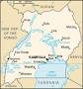

Key
Lakes River
- L.Victoria 1- R. Nile i. Buvuma Island
- L.Edward 2- R. Aswa ii. Buyala Island
- L. George 3- RAchwa iii. Kome Island
- L.Albert 4- R. pager
- L. Kyoga 5-R. Nkusi
- L.Bunyonyi 6- R. Mpologoma
- L. Nabugabo 7. R. Mayanja iv. Ssese Island
- L. Nakivali 8-R. Katonga
- L Wamala 9- R. Kafu

Reference
Monitor SST pbk4 pg 6 comprehensive SST pbk4 pg 8.9
Pri sch Atlas pg6

Types of rivers
- Permanent rivers.
These flow throughout the year seasonal rivers They are small and flow only during wet season and dry up in the dry season
- Sources of rivers
Rivers originate from
High lands, Lakes, swamps
- Tributary
A tributary is a small river joining a big/larger river
- Distributary. Is a branch of a large river (a small river branding of the major river

Reference
Monitor SST pbk4 pg6
Primary school atlas pg 6
Comprehensive SST pbk4 pg 8-9

Plains and valleys
Plains are low lying areas
Most rivers flow through plains before pouring their water into lakes, Ocean and Seas
Most plains receive little rainfall.
Importance of plains
- Plains are good for keeping animals since they have grass
- They are good habitats for wild animals
- Plains are also suitable for farming

SUB TOPIC: VEGETATION;
Definition: Vegetation is the plant life cover on the earth’s surface

Examples of vegetation
Forests, swamps, grasslands, pasture and crops semi-arid lands shrubs
Types of vegetation
There are two types of vegetation
Natural vegetation
Planted vegetation

Natural vegetation
This is the plant cover that grows on its own for example forests and grasslands swamps

Planted vegetation
This is the plant cover planted by people for example planted forests, crops, flowers etc.

Uses of vegetation

- It is a source of herbal medicine
- It is a source of fire wood
- It is a source of fruits
- It helps in rain formation
- It controls soil erosion
- It serves as wind breaks
- It is for beauty
- It improves on soil fertility
- It releases oxygen to the atmosphere

How people affect vegetation
Positive effects
- Afforestation
- Re-afforestation
- Agro forestry

Negative Effects
- Bush burning
- Deforestation
- Over cultivation
- Over grazing
Human activities done by people that destroy vegetation
- Brick making
- Road construction
- Building houses for settlement
- Building industries

Ways of caring for vegetation
- By watering vegetation
- By adding manure to vegetation
- By pruning vegetation
- By fencing vegetation

Reference:
Monitor SST pbk4 pg 10
Sharing our world pbk4 pg 14
MK SST pbk4 pg 12
Comprehensive pbk4 pg 14-15

SUB-TOPIC: Forests
Definition

A forest is a group of trees growing together
Uses of forests

- Forests help in rainfall formation
- They are a source of timber
- Forests provide us with both animal and plant food
- They are homes of some wild animals
- Forests attract tourists
- They control soil erosion
- Forests provide raw materials for hand crafts
- They also help in preserving water in the soil
- They are a source of herbs to people
- They are a source of wood fuel

Dangers of forests

- Forests are habitats for dangerous wild animals
- They are hide out places for wrong people
- They make road construction difficult

Types of forests
  - Natural forests
  - Planted forests
Natural forests
These are a group of trees that grow by themselves

Examples of natural forests in Uganda

- Mabira forest - Buyikwe district
- Bugoma forest - Hoima district
- Bwindi Impenetrable forest - Kabale
- Budongo forest - Masindi district
- Maramagambo forest - Mbarara/Bushenyi
- Mt.Elgon forest - Mbale district
- Marabigambo forest - Rakai district
- Kibale district - Kabarole district
- Ssese island forest - Kalangla district

We get hardwood from natural forests

Examples of trees found in natural forests
Mahogany, Mvule, Walnut, Teak, Ebony
The above trees give us hard wood which is used for making timber and for building

Planted forests
These are groups of trees planted by man

They include:

Lendu - Nebbi district
Mafuga - Rukungiri district
Katuugo - Nakasongola district
Nabyeya - Masindi district
Bugamba forest - Mbarara district

We get soft wood from planted forests

Uses of soft wood
- It is used for making paper
- For making match boxes
- For making ply wood
- For making some musical instruments
Examples of trees that grow in planted forests

- Eucalyptus,
- Cypress,
- Pine,
- Cedar

Characteristics of planted forests
- Trees are planted in rows
- Trees grow faster
- Trees have both soft and hard wood

Problems facing forests
- People carry out deforestation
- People burn bushes and fire destroys forests
- People carry out charcoal burning
Why do people cut down forests
- People cut down forests for timber
- To get land for settlement
- To get land for agriculture/farming
- To get land for industrialization

Care for forests
- Encourage people to plant trees (afforestation)
- People should plant trees where they have been cut (Re-afforestation)
- Farmers should plant trees together with crops (agro forestry)
- We should always report those who cut down trees
- People should stop bush burning near forest areas

SWAMPS
A swamp is a water logged area with vegetation
Swamp reclamation is the draining of water from swamps for human use

Importance of swamps
- Swamps help in rain formation
- They are a source of water
- They attract tourists , they are homes of animals and birds
- They are fishing grounds
- They are a source of craft materials e.g. clay, papyrus
- Swamps are used for growing crops like yams, rice and sugarcanes
- Swamps provide building materials like papyrus

REFERENCE:
MK Std S.S.T pbk4 pg 11-13
Monitor S.S.T pbk4 pg 12

Subtopic: Grass lands

A grass land is an area mainly covered by grass and scattered trees
In Uganda, there are two types of grasslands
These are:
- Dry savanna
- Wet savanna

Dry Savanna
These grow in places that receive little rainfall

Wet Savanna
Wet Savanna grassland grow in places that receive average rainfall.

Importance of grasslands
- They are used as grazing areas for livestock
- They are homes of wild animals
- Grasslands prevent soil erosion
- Grass is used for thatching houses
- Grasslands control desert formation
- Grasslands is used for mulching gardens
- They help in rain formation
- Some of the dry Savanna grassland are set aside as game parks

Examples of game parks in Uganda
- Murchison falls National Park (Largest in Uganda)
- Queen Elizabeth national Game Park etc (Second largest)
- Kidepo valley National Game Park
- Mt. Elgon National Game Park

Reference:
MK SST pbk4 pg 14
Comprehensive SST pbk4 pg 18 and 17
Monitor SST pbk4 pg 11-12
Sharing our world pbk4 pg 15

Land use pattern in our district

Land means the ground which people own
It is a basic need of man

Land is divided into two groups, namely
- Urban land
- Rural land
Urban land is found in towns
Rural land is found in villages

Uses of land to man
- For growing crops
- For rearing animals
- For building houses and industries
- For constructing roads
- For mining
- For recreation (playing and enjoyment)
- Land provides us with sources like water, clay, sand etc

How to care for land
  - By using good farming methods
  - By manuring the land

How land is acquired
  - By buying the land
  - Through inheritance
  - Through renting

Things that affect land use
    - Physical features-Highlands lakes/rivers can make building and transport difficult.
    - Climate -Very hot/dry areas are not good for crop growing.
    - Diseases - some areas are unhealthy for people to live in for example when there are tsetse flies, mosquitoes etc.
    - Wars - in places where there were war, people killed and the very few who remain cannot use it well.
    - Transport - when factories, plantations and other businesses are put near the road, it is easy to transport the goods to the areas where there is market.
    - Mining - where there are minerals the land is used for mining

Reference:
Sharing our world pbk4 pg 15
Mk pbk4 pg 14
Mk Trs guide bk4 pg 407

Revision question
- Define a forest.
- How are forests important to people?
- Write down the two types of forests.
- Identify any two planted forests in Uganda.
- Write the districts in which the following forests are found.
  - Bugoma forest
  - Budongo forest
  - Mabira forest
- Which type of wood is got from planted forests?
- Write down two examples of trees found in natural forests.
- State two problems faced by forest in Uganda.
- Why do people cut down trees?
- Define the following terms
  - Afforest ration
  - Reforestation
  - Deforestation
- How are swamps useful to use?
- Identify any two crops grown in swamps
- What do you understand by the term “vegetation?”
- Identify the two types of vegetation
- How are grasslands important?
- Identify any two uses of land to man
- How are game parks important?
- Write two factors that may affect land use in Uganda

TOPIC: WEATHER IN OUR DISTRICT

SUBTOPIC: Weather is the condition of the atmosphere at a given time or place.

Types of weather

- Windy
- Sunny

- Cloudy
- Rainy

Elements of weather

- Rainfall
- Cloud cover
- Temperature
- Wind

.

Activity
Draw the types of weather

Clouds
Clouds are a mass of condensed water

Types of clouds
Nimbus clouds They are very dark and low
They give steady rainfall
Cumulo-Nimbus They are lighter than nimbus clouds. They appear high in the sky and grow bigger when land
Cirrus clouds They are very high. They appear not to be moving is hot and normally show a clear weather
Stratus clouds They are grey in colour. They look like a blanket spread all over the sky

Importance of clouds
- Clouds bring rainfall
- They protect us from direct sunshine
- Protect us from direct rain
- Clouds helps to keep the place cool
- They keep the earth warm at night

Dangers of clouds
- Large and dark clouds can cause crushing of the aeroplanes.

Reference
MK prim. SST pbk4 pg 14
A new pri pbk4 pg 18-19

Activity
MK Std SST pbk4 pg 18 and 14
Compressive SST pbk4 pg 19
A new prim SST for Uganda pbk4 pg 23

Rainfall

Rainfall is the total amount of rain that falls in a particular area.
Rain is the water that falls from the sky in separate drops
Rain is the main natural source of water

Types of rainfall
- Relief rainfall (or graphic rainfall
- Cyclonic rainfall (frontal rainfall
- Convectional rainfall
Convectional rainfall
This type of rainfall is commonly received around large water bodies and forests.
Conventional rainfall is mainly received around L. Victoria and the rest of the central region

Formation of convectional rainfall
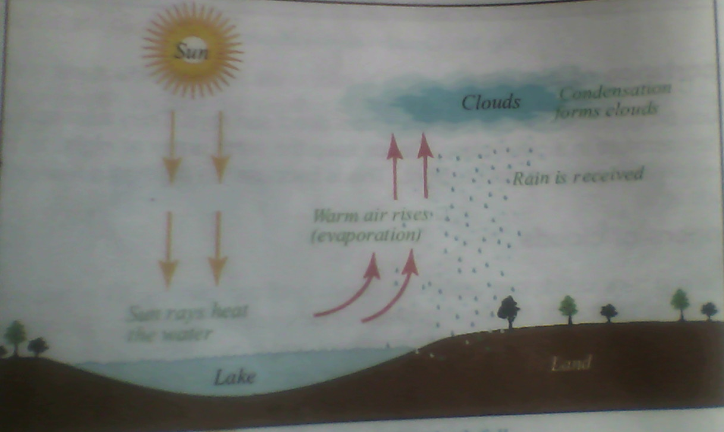

Reference
MK Std SST pbk4 pg 20
Comprehensive SST pbk4 pg 15-23
A new primary SST for Ug. bk4 pg 23
Monitor SST pbk4 pg 16

Relief rainfall
It is also called or graphic rainfall
It is received in areas around highlands (mountains and hills)
Formation of relief rainfall (Orographic)
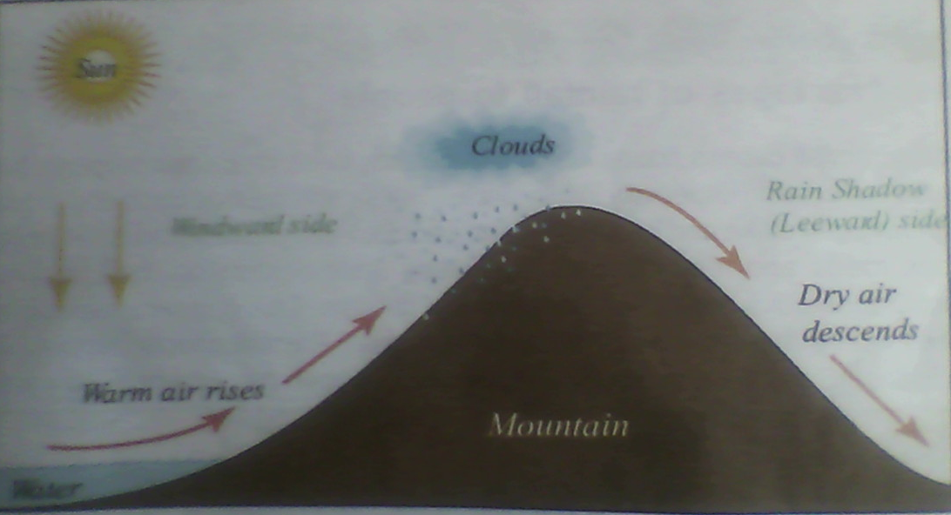
- The wind word side receives rainfall
- The lee ward side (rain shadow) receives little or no rainfall
- The leeward has dry wind which cannot form rainfall
- Areas in Uganda that receive relief rainfall
- Around Mt. Elgon Mbale, Kapchorwa, Sironko
- Around Mt. Rwenzori Kasese

Reference:
MK Std SST pbk 4 page 21
MK std SST Trs guide bk4 pg 48
Comprehensive SST pbk4 pg 19

Cyclonic rainfall
Cyclonic rainfall is also called frontal rainfall
It is received in flat areas
Formation of cyclonic rainfall

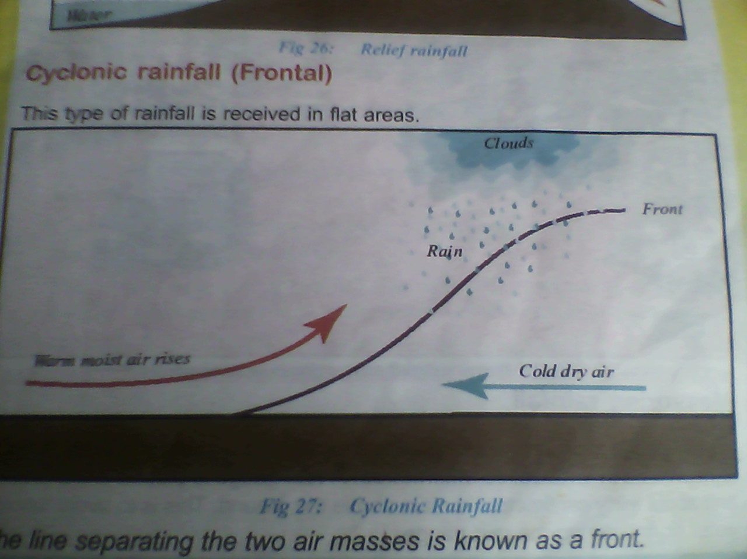

Areas that receive frontal rainfall are in the northern Uganda
The line separating the two air masses is called the front

Reference
Mk SST pbk4 pg 22
MK Trs guide pg 408

Advantage of rain fall to man
- Rain is the major source of water
- It softens the soil for cultivation
- It helps crops to grow well
- Rain adds on the level of rivers, lakes stream and wells
- It enables plants to make their own food

Disadvantages of rainfall
- Heavy rains cause floods which can destroy lives, crops and property
- Heavy rains can break bridges
- Rain encourages quick spread of diseases for example cholera
References
MK SST pbk4 22
MK Trs guide bk4 pg 48

Measuring rainfall
Rainfall is measured using a rain gauge. It is measured in millimeters
A rain gauge is placed in the ground and about 30cm remain above the ground. This is to avoid running water from entering the rain gauge.
A rain gauge helps a farmer to know whether there enough water in the ground
A rain gauge is placed in an open place to receive direct rain drops
Rain gauge
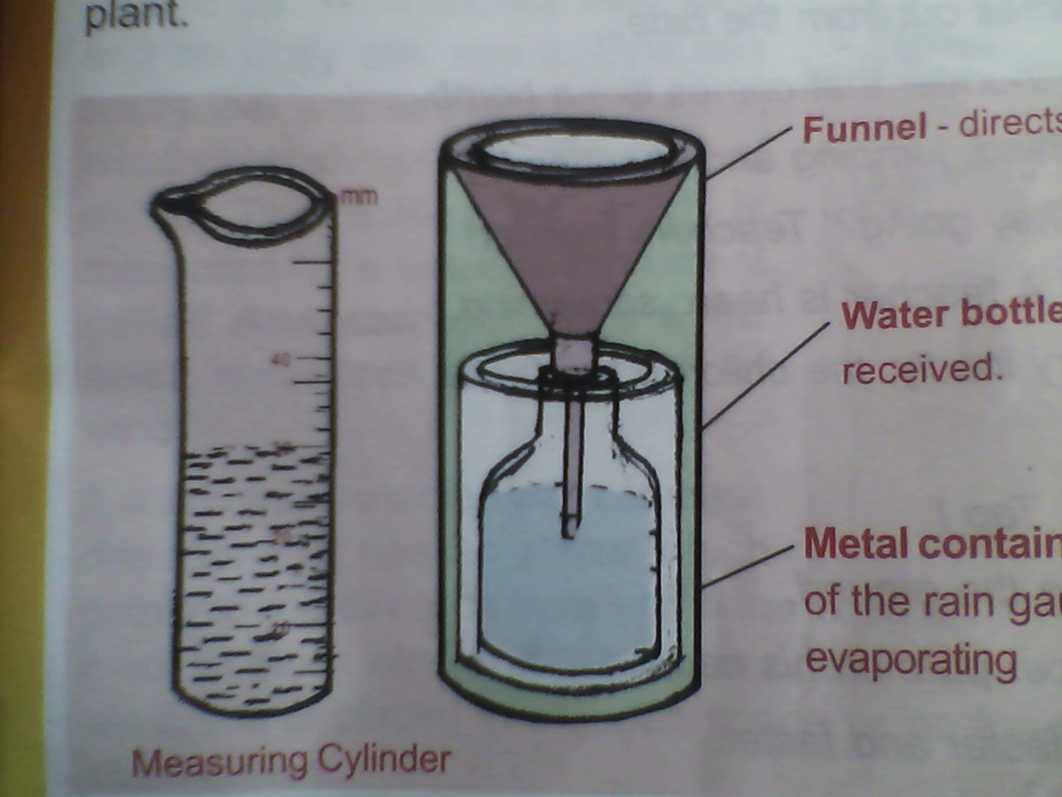
Metallic container
Funnel
Metallic container
Collecting bottle
Overflow can
Measuring cylinder
Reference:
MK SST pbk4 pg 23-26
Monitor SST bk4 pg 21

Wind
Wind is moving air in the atmosphere
Wind instruments
- Wind vane
A wind van is used to show the direction of wind
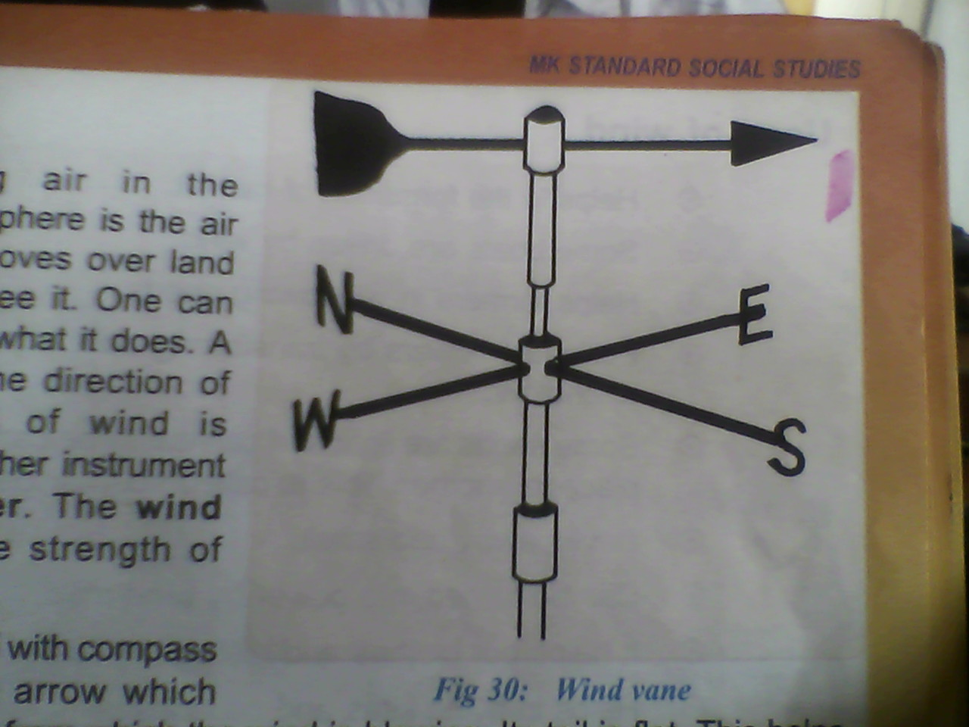
- Wind sock
A wind sock shows the direction of wind
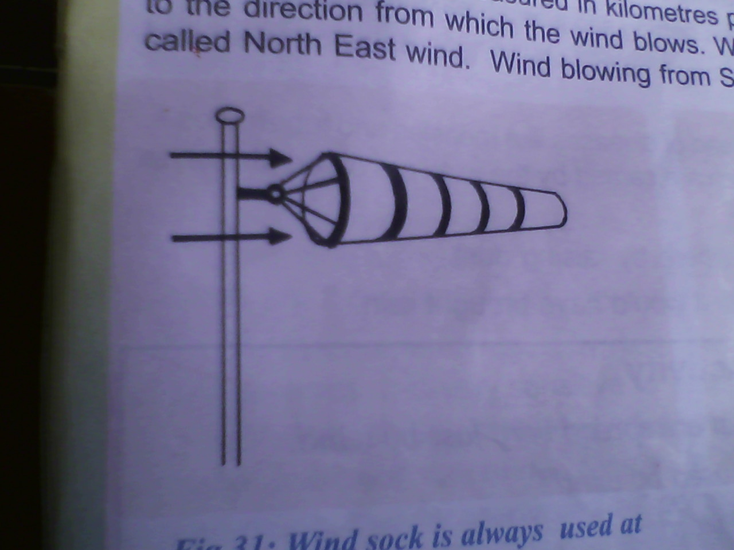

- Anemometer
Anemometer measures the speed to wind in kilometers
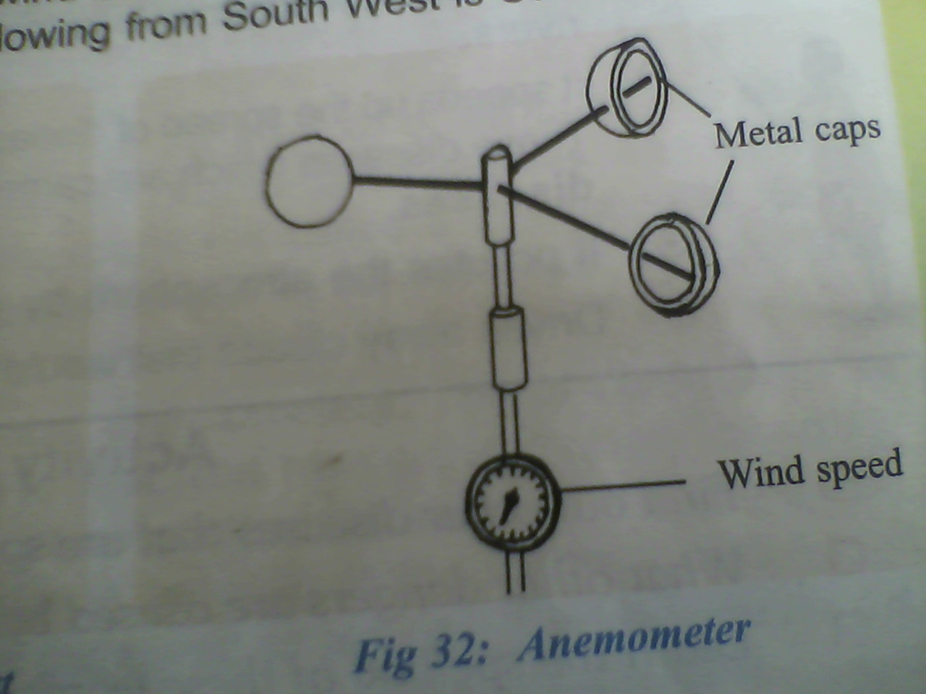
Uses/advantages of wind

- Wind helps in rain formation.
- Wind helps in flying kites and balloons.
- It drives away bad smell.
- Some boats are driven by wind.
- It helps in drying clothes.
- Wind helps in wind dispersal.
- It helps in pollination of flower by transferring pollen grains.

Dangers of wind
- Strong wind can blow roofs off houses
- It pollutes the atmosphere by raising dust
- Wind causes soil erosion
- It breaks tree branches
- It drives away clouds that would bring rain
- It speeds up the spread of diseases like measles and tuberculosis (Airborne diseases)

Reference
Comprehensive SST pbk4 pg 23
Mk SST bk4 23-26
Monitor pbk4 pg 14
Fountain pbk4 pg 16

Other instruments

Barometer
It is used to measure air pressure.
Air pressure is the force of air against any surface from any direction

Hygrometer
A hygrometer is used to measures humidity
Humidity is the amount water vapour in the atmosphere
The wet and dry bulb thermometer is the common type of hygrometer
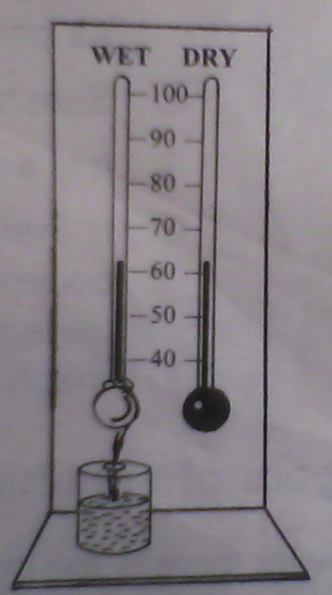

Thermometer
A thermometer is used to measure temperature
Temperature is the hotness or coldness of a place or object
It is measured in degrees

Types of thermometer
Clinical thermometers
It is also called the doctor’s thermometer
It is used to measure the temperature of a human body
The normal body temperature is 37⁰C OR 98.4⁰F

A Clinical thermometer
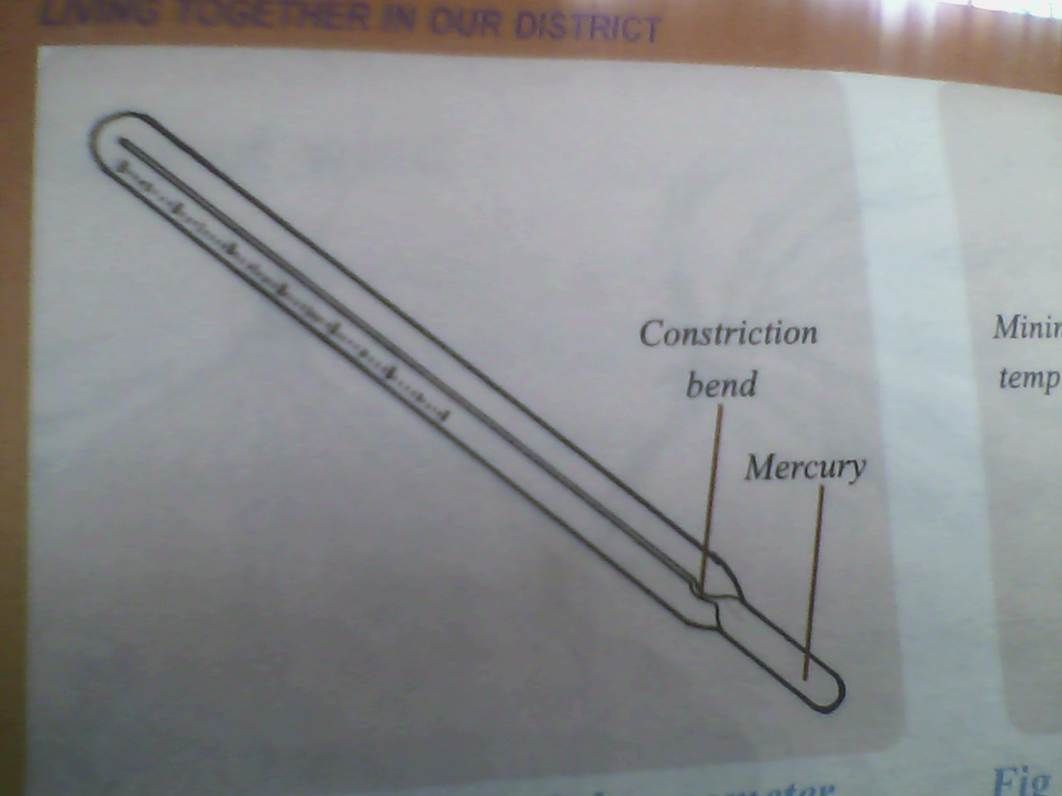
A clinical thermometer can used either centigrade or Celsius scale and the Fahrenheit scale
Places where the thermometer is placed
- In the armpit
- In the anus
- In the vagina
Note: The kink prevents the back flow of mercury before the doctor reads temperature
Why is the bulb thin? So that the mercury warms up quickly
Why is the bore very narrow? To have an accurate scale
The six’s thermometer or maximum and minimum thermometer
It is used for measuring the atmospheric temperature temperatures we shown on the maximum side while low temperature are shown on the minimum side
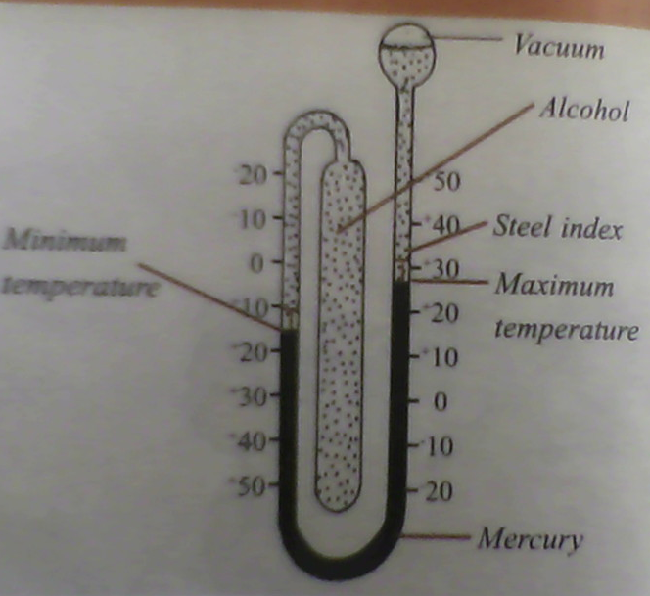
Reasons why mercury is used in thermometers
Mercury is a liquid metal or a metal liquid. It has the following advantages over alcohol

Mercury Alcohol
Mercury is coloured and it is easily seen Alcohol is colourless
Mercury does not wet or stick to the glass Alcohol wets the glass
Mercury is a good conductor of heat and it expands

Easily Alcohol does not expand

Advantages of alcohol over mercury
Alcohol does not solidify easily
Alcohol expands faster
References
Monitor SST pbk4 16-17
Mk pbk4 pg 27-28

Sunshine recorder (Campbell’s Sunshine recorder)
It is used to record the number of hours the sun shines a day
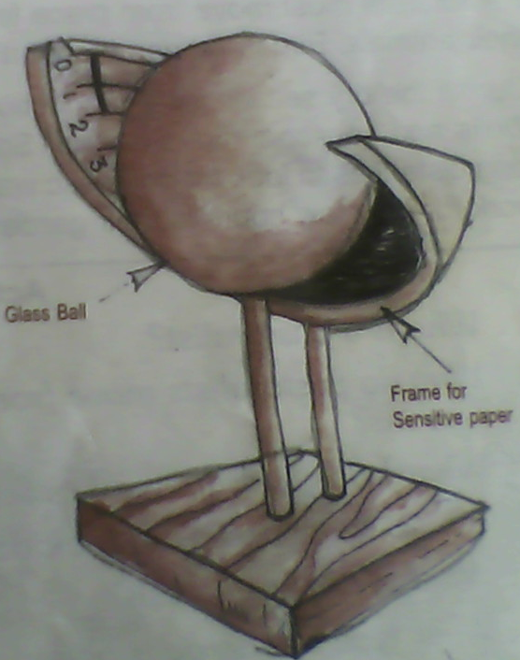

Advantages/uses of sunshine
- The sun gives us light and heat
- It helps plants to grow
- Sunshine helps in formation of rain through evaporation
- It helps us to dry our crops after harvesting for example coffee, cotton beans, soya etc
- Fishermen dry their fish in the sun
- Sunshine helps do dry our clothes

Disadvantages of sunshine
- Too much sunshine dries the water in the soil causing plants to wither
- It dries up wells and lakes
- Too much sunshine causes drought

Activities done in the dry season
- Harvesting
- Preparing land for next season

Reference
Our lives today SST pg 19-21
Monitor SST pbk4 pg 20
Fountain SST bk4 pg 10-11
The weather station
A weather station is a place where weather records are measured and recorded

Terms used:
Weather forecast
This is the telling of future weather changes
It helps a farmer to know when to plant/harvest their crops

Meteorology.
Meteorology is the study of weather conditions
Meteorologist.
Meteorologist these are people who study weather conditions
Climate
Climate is the average weather condition of a place recorded for a long period of time.

How is important is a weather station?
A weather station is a place where weather elements are measured and recorded
The Stevenson screen
Delicate weather instruments are kept in the Stevenson screen
These are: Hygrometer, Barometer Six’s thermometer
A Stevenson screen is painted white to reflect light and regulate heat

Why is a Stevenson screen put in an open area a way from buildings and trees
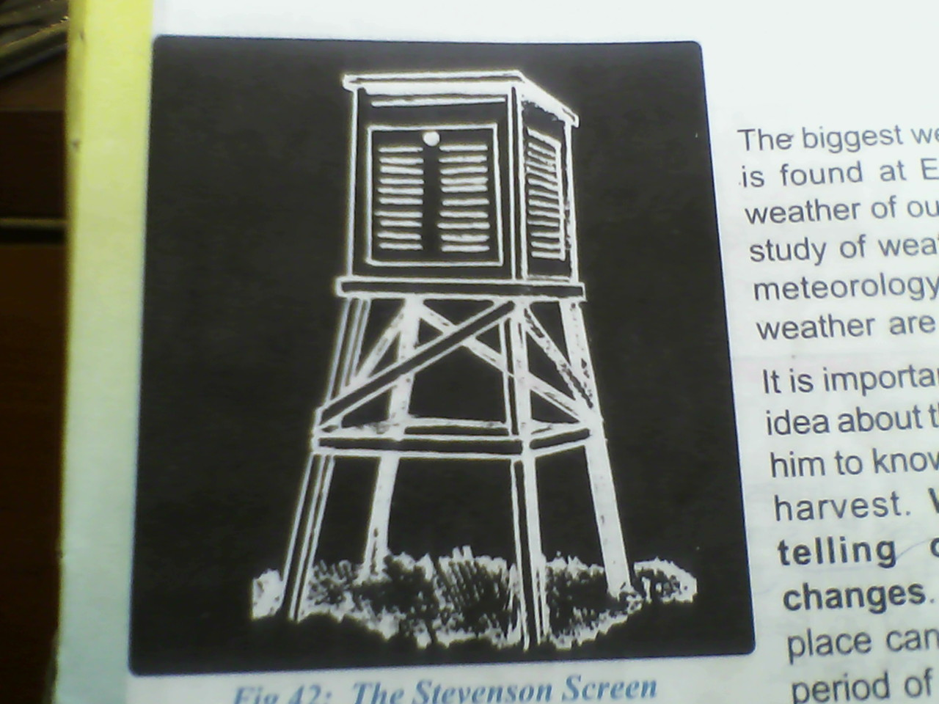
A Stevenson screen
A Stevenson screen has openings all round to allow in fresh air

Revision question

- Define the term weather
- Write down the four types of weather

- How are nimbus clouds important to farmers?
- Identify any two elements of weather
- Write any one danger of clouds
- Mention the three types of rainfall
- Where is convectional rainfall received
- What name is given to the line that separates the two air masses during the formation of cyclonic rainfall?
- Give two advantages of rainfall
- Write another word of mean relief rainfall
- How useful is rainfall to the people of Uganda
- What is a rain gauge?
- How is moving air called?
- Write the instruments for measuring for the following
  - Speed of wind
  - Air pressure
  - Direction of wind
  - Humidity
  - Temperature
- Write down the two liquids used in thermometers
- What is the use of the constriction on the thermometer?
- Why is the bore very narrow?
- Give two advantages of sunshine
- Why is mercury used in the thermometers?
- How is sunshine advantageous to us?
- How is weather forecast important to a farmer?
22. Define the following
  - Meteorology
  - Meteorologist
  - Climate
23. Why is the Stevenson screen painted white?

E N D

